**Task 6 – Driving Eligibility**

**Algorithm**• Use prompt() to ask the user for their age.

• Convert the input to a number using Number().

• Use an if-else structure:

* If age is **greater than or equal to 18**, the user is eligible.
* Else, the user is not eligible.

• Display both input and result in the **console** and **alert**.

**Psudocode**

START

PROMPT user for age

CONVERT to number

IF age >= 18

DISPLAY "Eligible to drive"

ELSE

DISPLAY "Not eligible to drive"

END

**Code(javascript)  
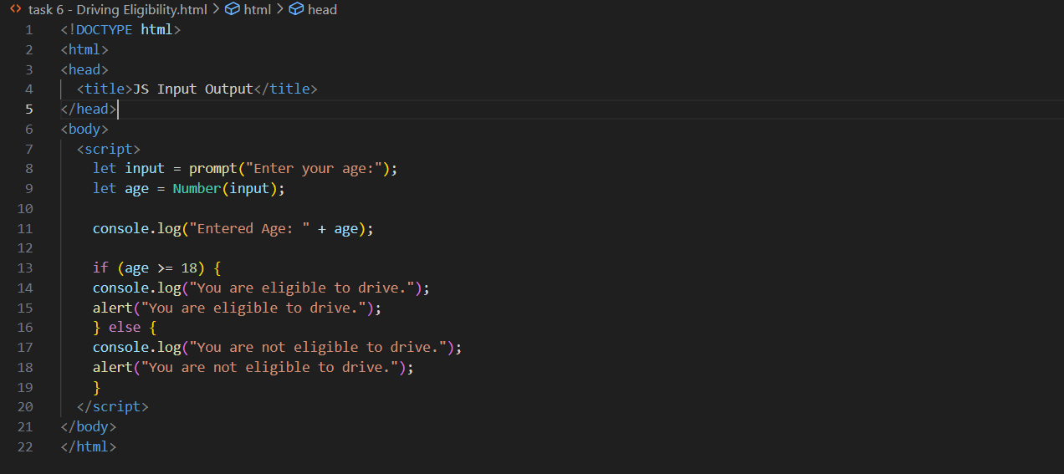**

**Output (test case 1)**

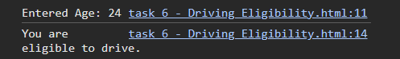  
**Output (test case 2)**

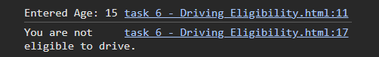  
**Observations**

• Accepts age input as a number and applies a simple condition (age >= 18).

• Demonstrates clear decision-making using an if-else block.

• Input and result visibility in both console and alert helps in understanding the flow.

• A realistic beginner-level task used to teach conditional logic in real-life scenarios.